WEEK - 8
Yash Raj
SuperSet ID - (6364442)

1.Git-HOL
Installing Git
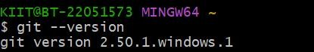
Configuring the username and user-email
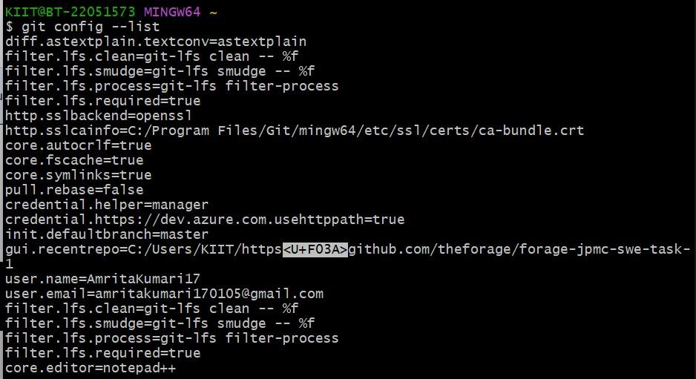
Making new folder and initializing git
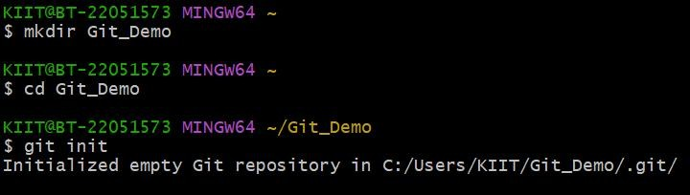
Creating and checking the file
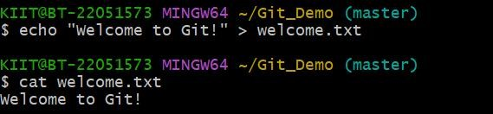
Adding file to git and commit
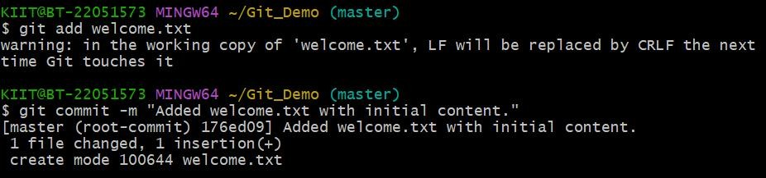

Creating GitLab respository
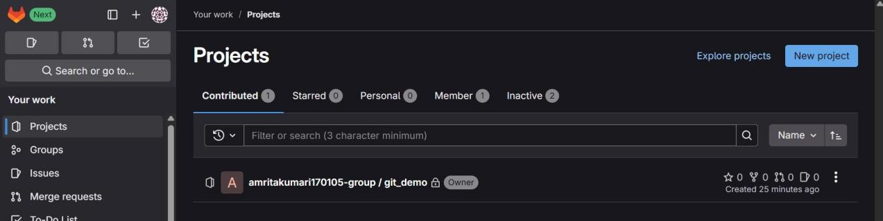
Link - https://gitlab.com/amritakumari170105-group/git_demo.git Add remote and push to gitlab
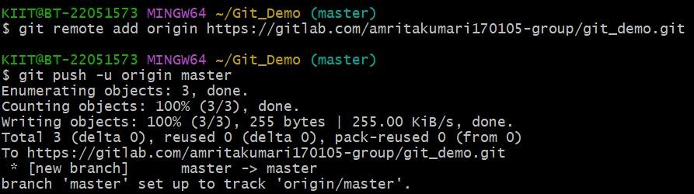

Confirming on GitLab:
